[FINAL DELIVERABLE](https://www.canva.com/design/DAGmvPlf55g/QSK48Bta-9xUZgHUGLzAWA/edit?utm_content=DAGmvPlf55g&utm_campaign=designshare&utm_medium=link2&utm_source=sharebutton)

Overview

This plan provides a step-by-step guide for preparing, formatting, and uploading datasets from Landover Hills to the Maryland Open Data Portal. It includes formatting standards, metadata practices, georeferencing instructions, and recommended methods of data upload.

Selecting a Method of Data Upload

### 

| Method | Pros | Cons |
| --- | --- | --- |
| Uploading a Data File | Simple and supports many formats (CSV, Excel, JSON, etc.) | Manual updates are required |
| Importing from URL | Easy to connect to external data | Sensitive to formatting issues in source |
| Connecting via Socrata Gateway | Fully automates updates and works with many formats | Most complex to set up; requires coding and IT setup |
| Linking to External Source | Quick to offer spreadsheet downloads | Less functionality (no visualizations, API, etc.) |

### For now, we recommend Landover Hills usefile uploads to begin its open data initiative.

Identify and Prepare Datasets

The first step in the implementation process is ensuring that your dataset is properly structured. The Maryland Open Data Portal requires that each field or data category (e.g., "Year," "Number of Permits Issued," or "Address") be presented as a separate column, with each row representing a unique entry or record. In some cases, datasets may originally be arranged with information in rows instead of columns—this is a common issue, particularly with manually maintained spreadsheets. In such cases, transposing the data in Excel is necessary. On a PC, the shortcut is Control+Alt+V. On a Mac, it is Command+Control+V.

Incorrect format:

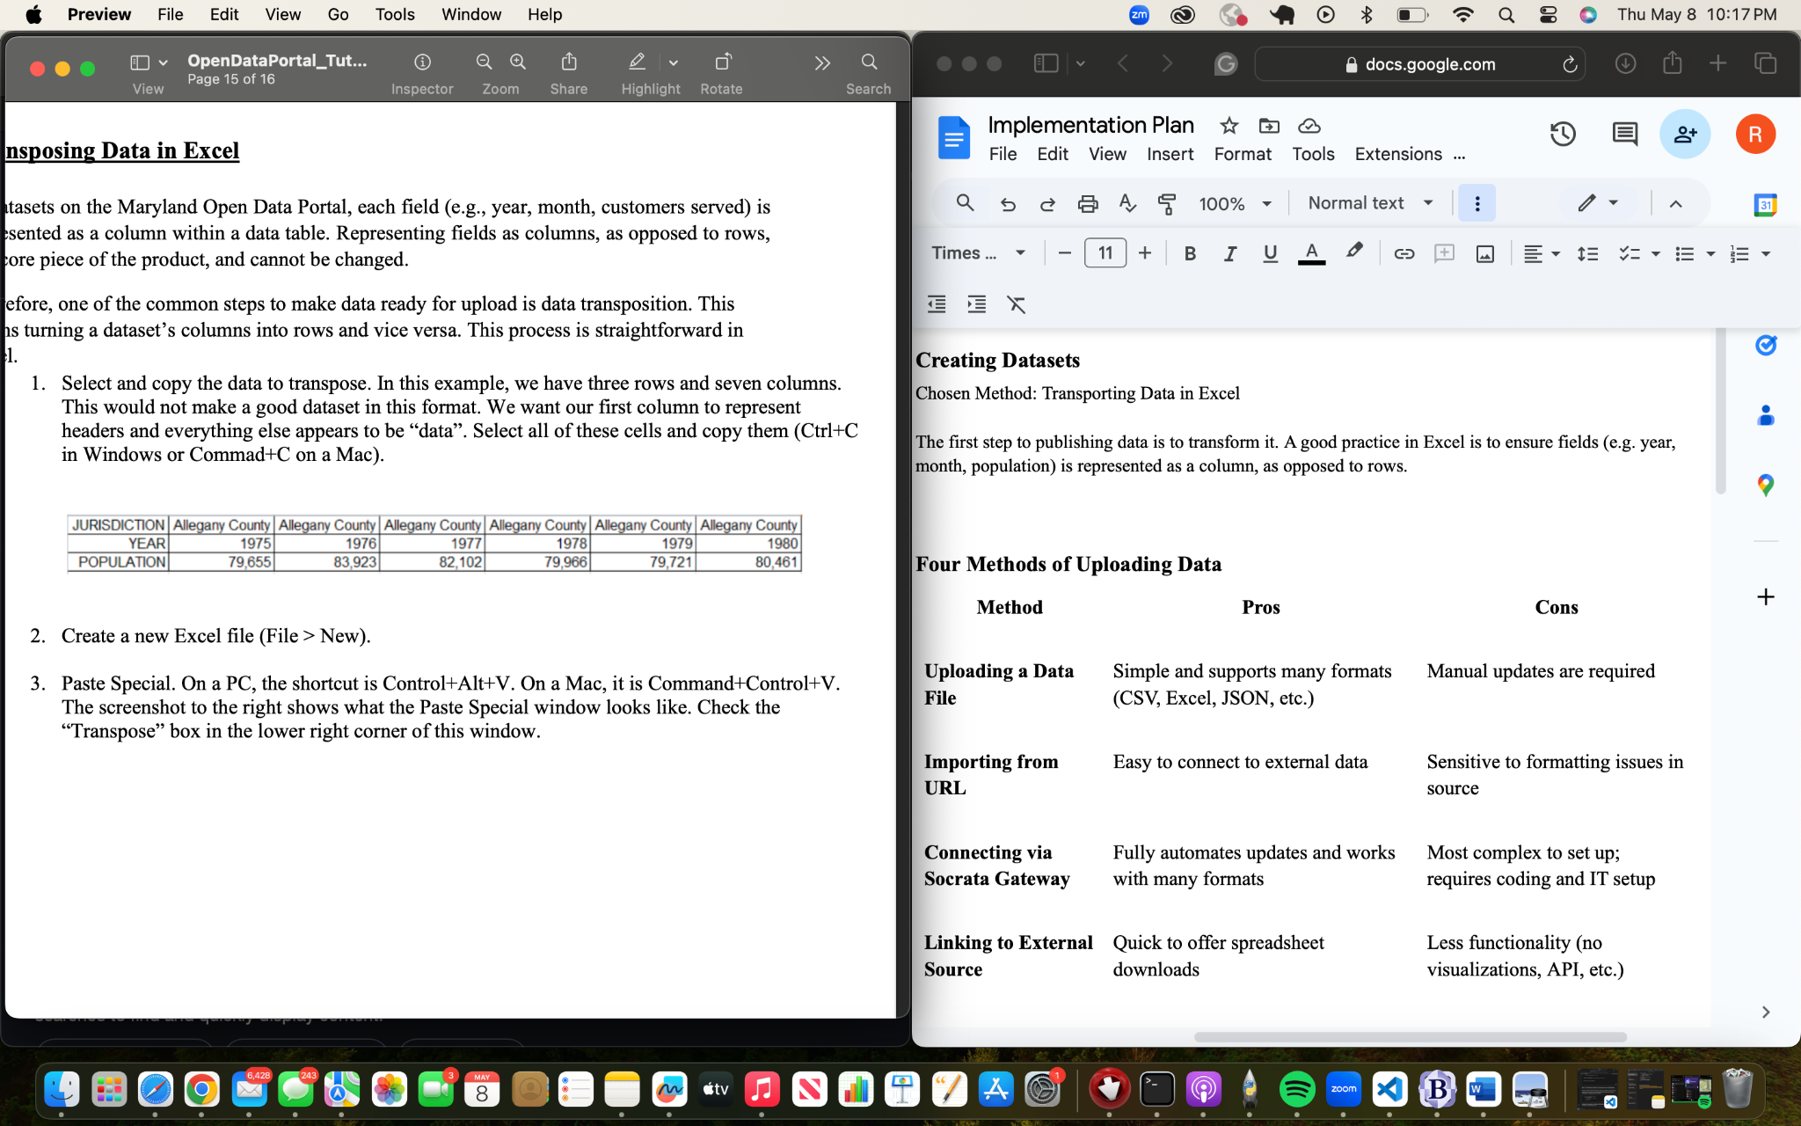

### Correct format:

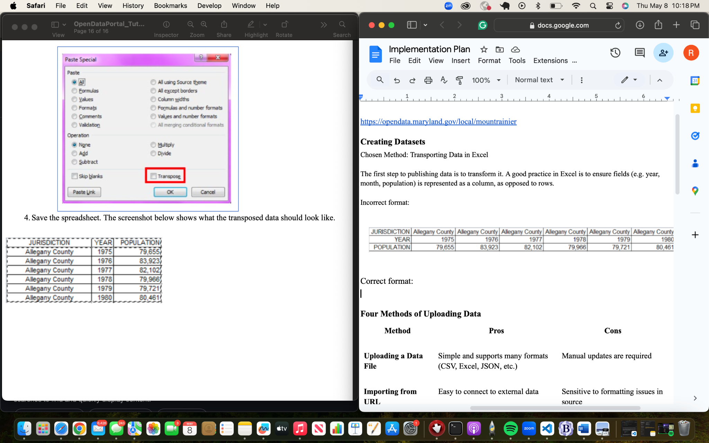

Creating New Dataset on the Portal

After your data is formatted correctly, log into the Maryland Open Data Portal at <https://opendata.maryland.gov/login>.

### A. Login and Create Dataset

1. From the dashboard, click the “Create” drop-down menu and select “Dataset.”
2. Give your project a clear, descriptive title, such as “Landover Hills Building Permits 2020–2023.” This title will be publicly visible and should be easily identifiable for both internal use and for citizens browsing the portal.
3. To upload your data, click “Add Data” and then select the file from your device. Supported formats include .csv, .xls, .xlsx, and .tsv.

### B. Format the Dataset

1. Once uploaded, you’ll be taken to the “Review & Configure Data” screen, where you can preview and edit the dataset before publishing. It is essential to review how the system interpreted your column names and data types.
   1. For ex., a column labeled “Date” should be recognized as a date field
2. You can rename columns, provide brief descriptions (e.g., “Permit Type – Describes the classification of the permit issued”), rearrange the column order, and hide any columns that are not relevant to the public.

C. Adding Metadata & Publishing

Metadata provides critical context about the dataset

1. Click “Edit Dataset Metadata” to complete required fields such as:
   1. Title: E.g., “Landover Hills Code Violations FY2020–2023”
   2. Description: Include the source of the data (e.g., Town Clerk’s Office), the purpose (e.g., transparency and community awareness), and how often it will be updated (e.g., quarterly).
   3. Tags: Add searchable keywords like “housing,” “code enforcement,” or “Prince George’s County.”
   4. License: Most datasets will be marked as “Public Domain.”
   5. Time Period: Indicate the timeframe your data covers.
   6. Contact Email: Enter a monitored town email for public questions or follow-ups.
2. Once everything is configured, click “Publish Dataset” in the top-right corner to submit your data. The system may queue your dataset for administrative review before it goes live.